Average amount of applicants per a month from 2014-2016 is 150.5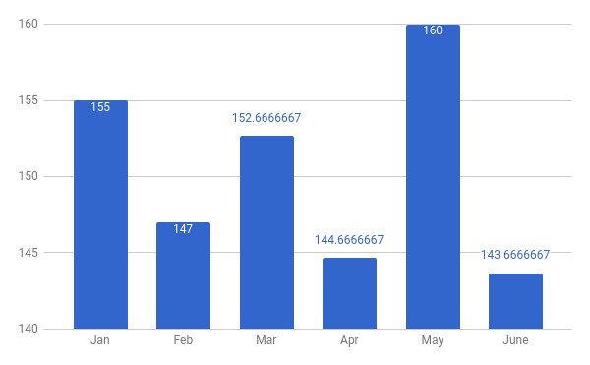Of the monthly average, 71.1 or 49.24% were female

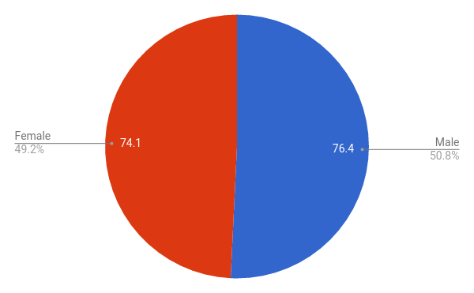

Applicants per month for each gender

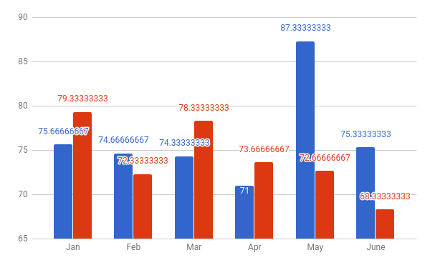

2017 Average Scores 1st Quarter

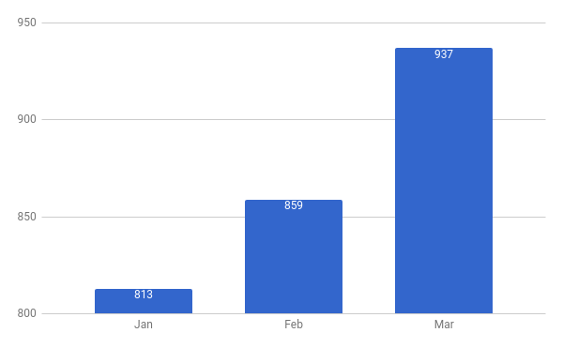

Male average is 4.9285

Female average is 5.78

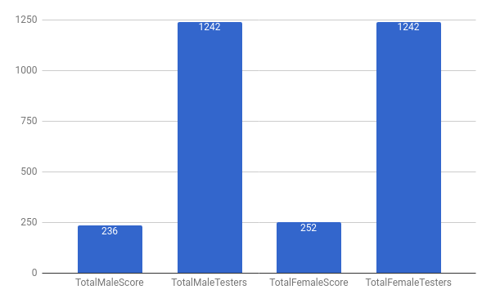

Projected Applicants for Second Quarter

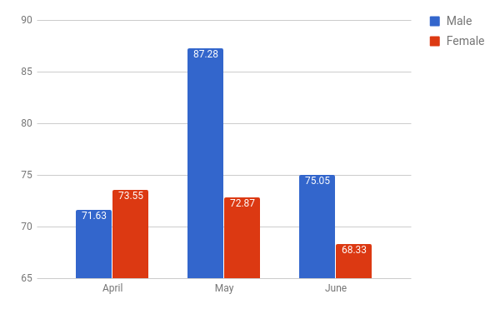

Projected Average Scores for Each Gender for Second Quarter

